- Write a C program to perform factorial of a number.
#include<stdio.h>
int main ()
{int n,fact=1,i;
printf("enter the number you want to find the faactorial for :");
scanf("%d",&n);
for(i=1;i<=n;i++)
{fact=fact*i;}
printf("\nthe factorial is : %d",fact);
return 0;
}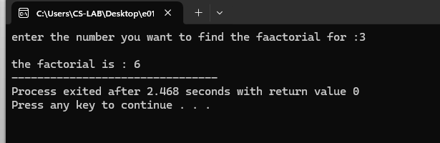
- Write a C program to find the Sum of n natural numbers.
#include<stdio.h>
int main ()
{int i,n,sum=0;
printf("enter the number :");
scanf("%d",&n);
for (i=1;i<=n;i++)
{sum += i;}
printf("\nthe sum is :%d",sum);
return 0;
}
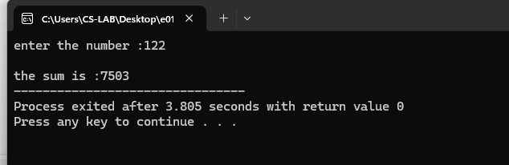
- Write a C program to find the Sum of n digits.
#include<stdio.h>
int main ()
{int i,n,r=0;
printf("enter the number");
scanf("%d",&n);
while (n>0){
r = n%10;
n /= 10;}
printf("%d",r);
return 0;

}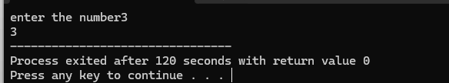
- Write a C program to count the number of digits of a given number
#include<stdio.h>
int main ()
{int i,n,c=0;
printf("enter the number");
scanf("%d",&n);
while (n>0){
c++;
n/=10;}
printf("%d",c);
return 0;

}
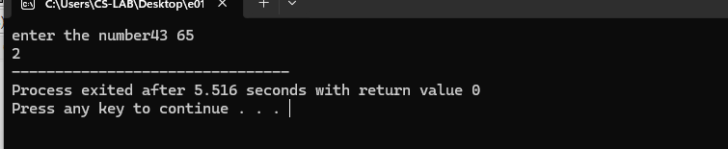

- Write a C program to print the Fibonacci Series
#include<stdio.h>
int main ()
{int n,f=0,s=1,next,i;
printf("enter the number of terms");
scanf("%d",&n);
for(i=1;i<=n;++i)
{
printf("\n%d",f);
next=f+s;
f=s;
s=next;
}
return 0;
}
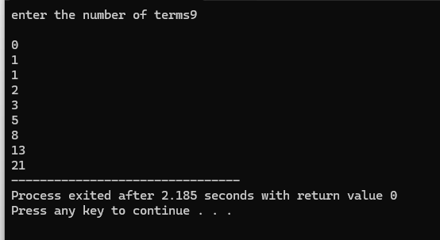
7.Write a C program to find the Reverse of a number
#include<stdio.h>
int main () {
int n,r,rev=0;
printf("enter the number of terms");
scanf("%d",&n);
while (n!=0)
{r = n%10;
rev = rev*10+r;
n /=10;
}
printf ("\n%d",rev);
return 0;

}
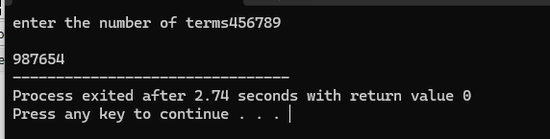
8.Write a C program to find the Maximum using Switch case
#include<stdio.h>
int main ()
{
int a,b,choice;
printf("enter the two number :");
scanf("%d%d",&a,&b);
choice= (a>b);
switch (choice) {
case 1:
printf("max=%d\n",a);
break ;
case 0:
printf("max=%d\n",b);
break ;
default:
printf("both numbers are equal");

}
return 0;
}
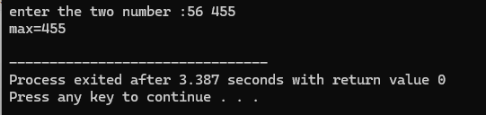

9.Write a C program for multiplication table
#include<stdio.h>
int main ()
{ int i,n;
printf("enter the number");
scanf("%d",&n);
for(i=1;i<=10;i++)
{printf("\n%d * %d = %d",i,n,i*n);
}
return 0;
}
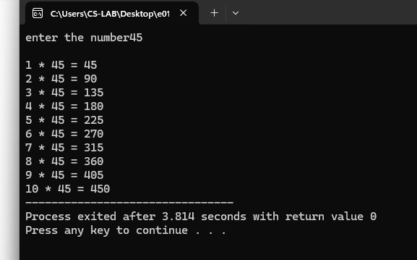

10. Write a menu driven program to perform arithmetic operations using Switch case.

#include<stdio.h>
int main (){

int c;
int a,b,r;
printf("menu driver calculater");
printf("\n addition (1)");
printf("\n subraction (2)");
printf("\n multiplication (3)");
printf("\n division (4)");
printf("\nenter your choice");
scanf("%d",&c);
printf("\nenter the two numbers :");
scanf("%d%d",&a,&b);
switch (c){

case 1:
printf("the addition is: %d",a+b);
break;
case 2:
printf("the subraction is: %d",a-b);
break;
case 3:
printf("the m is multiplication: %d",a*b);
break;
case 4:
printf("the division is: %d",a/b);
break;
default:
printf("invalid statement");
break;}
return 0; }
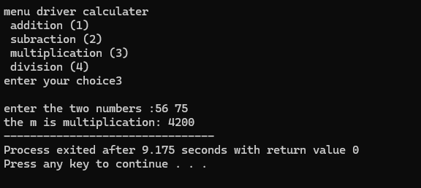
- Write a C program to print all the even numbers between 1 to 100.
#include<stdio.h>
int main ()
{ int i;
for(i=2;i<100;i+=2)
{printf("\n%d",i); }
return 0;
}
